Before Volume deletion
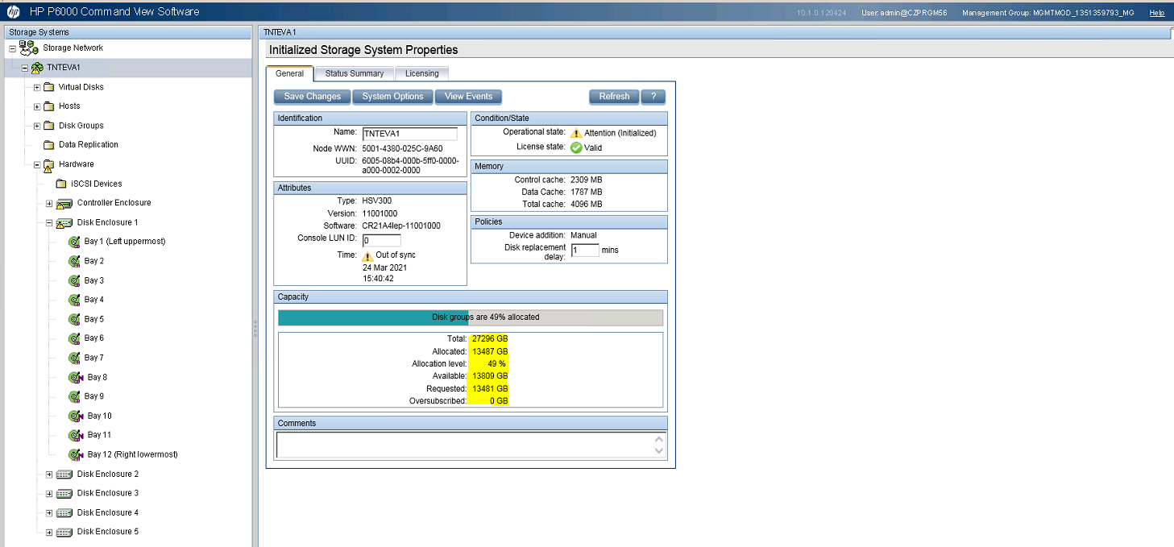

LUN | NAA | Status
VMFS HB_1-syslog(2GB) | 600508b4000b5ff00000a00002cd0000 | Deleted
VMFS HB_2-2GB | 600508b4000b5ff00000a000031e0000 | Deleted
VMFS_FASTFC_1-1500 | 600508b4000b5ff00000a00003630000 | Deleted
VMFS_FASTFC_2-2650 | 600508b4000b5ff00000a00003680000 | Deleted
VMFS_SLOWFC_1(5000GB) | 600508b4000b5ff00000a00002c70000 | Deleted

czprgs100.cz.tnt.com
czprgs101.cz.tnt.com
czprgs102.cz.tnt.com

czprgs10_boot----6005-08b4-000b-5ff0-0000-a000-026b-0000-----80GB-----Deleted
czprgs4_DATA_01-----6005-08b4-000b-5ff0-0000-a000-03dd-0000---550GB------Deleted
czprgs4_Mailbox-Archive------6005-08b4-000b-5ff0-0000-a000-03e3-0000----400GB-Deleted
czprgs6_DATA_01---------6005-08b4-000b-5ff0-0000-a000-03f4-0000—410GB---Deleted
czprgs100_boot-------6005-08b4-000b-5ff0-0000-a000-02ba-0000----5GB---Deleted
czprgs101_boot-------05-08b4-000b-5ff0-0000-a000-02be-0000 --------5GB---Deleted
czprgs102_boot-----6005-08b4-000b-5ff0-0000-a000-02c2-0000-----5GB----Deleted
czprgsxyz_boot----6005-08b4-000b-5ff0-0000-a000-0036-0000------80GB---Deleted
admin/Password123!

EVA4 before:

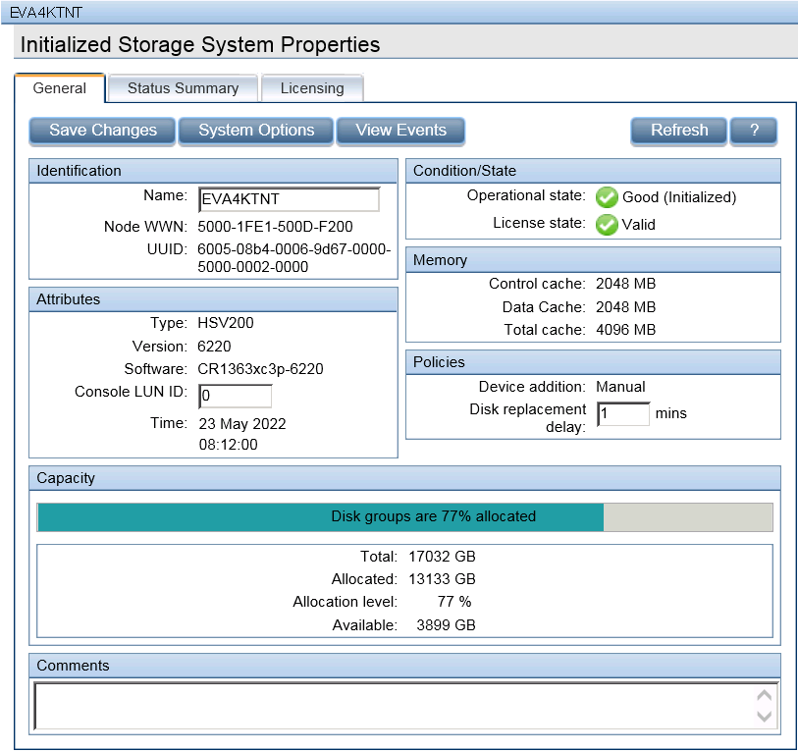
Volume
Volume before deletion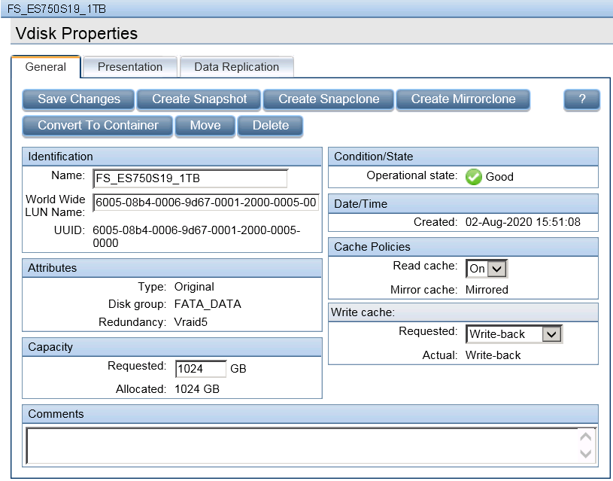
EVA4 after:

